**Wildanul Ahsan**

wildanul08@gmail.com

16/01/2023

1. Install python dan cek python version di terminal
2. Install Text Editor, misal visual studio code

**Note :** Capture Text editor dan python version, Upload ke drive

**Gambar** Versi Python 3.10.5 Yang Sudah Terinstall di Laptop

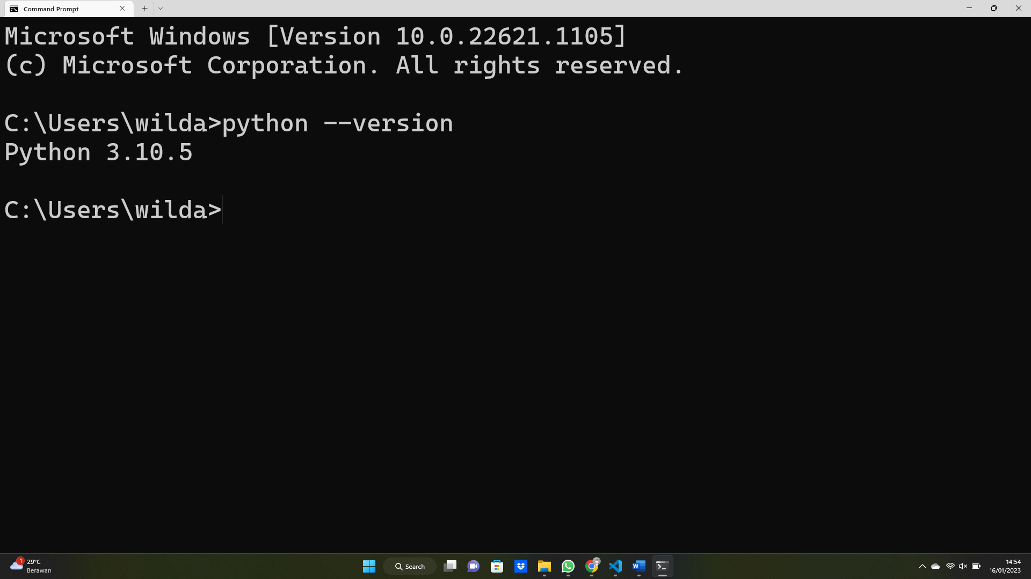

**Gambar** Text Editor Visual Studio Code

